**Experiment 4**

Valiveti Manikanta Bhuvanesh

19BCD7088

AIM: Write a program to perform linear regression analysis

**Code:**

x<-c(100,200,300,400,500,600,700,800,900,1000)

y<-c(1,2,3,4,5,6,7,8,9,10)

r<-lm(y~x)

print(r)

print(summary(r))

a<-data.frame(x=1200)

res<-predict(r,a)

print(res)

**Output:**

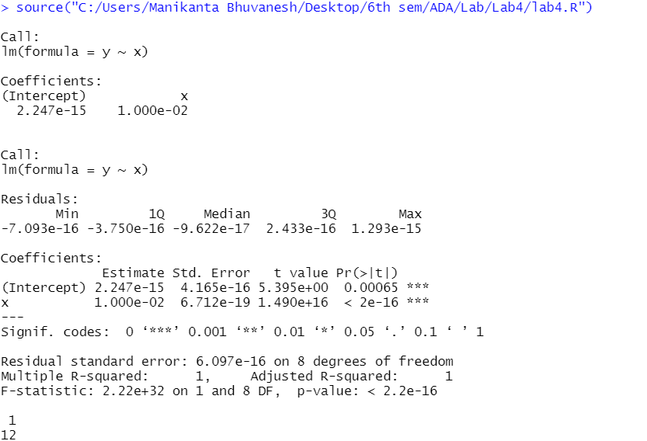

**Line Plotting:**

**Code:**

plot(y,x,col="blue",main="regression line",abline((lm(x~y))),cex=1.3,pch=16,xlab="quantity",ylab="tons")

**Output:**

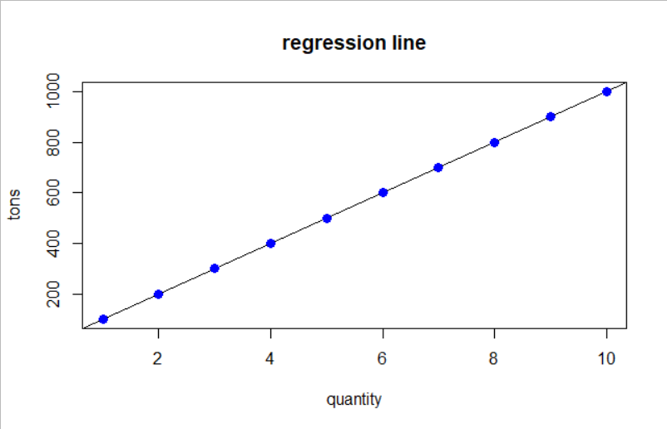

**Using Fish data set**

**Code:**

df<-read.csv('Fish.csv')

x<-df$Height

y<-df$Weight

r<-lm(y~x)

print(r)

print(summary(r))

a<-data.frame(x=1200)

res<-predict(r,a)

print(res)

plot(y,x,col="blue",main="regression line",abline((lm(x~y))),cex=1.3,pch=16,xlab="Height",ylab="Weight")

**Output:**



